**Report: Experiment 2.1 (ECS 327)**

**Date: 17th August 2021**

**Name: Rita Abani**

**Roll No: 19244**

**Title of Experiment: 2.1 Charging and discharging characteristics of capacitor using DC source.**

**Brief Description:**

This experiment involved performing some circuit simulations in LTSpice in order to understand the charging and discharging characteristics of a capacitor using a Voltage modulated by a Pulse in the advanced setting. When a discharged capacitor is connected to a DC voltage source it gets charged with an increase in the voltage of the source. Likewise, a charged capacitor discharges in opposite direction when the applied DC source voltage is reduced.

So in this lab, we built a circuit with a resistor, a capacitor and a DC source where we used the pulse feature to have a step function to study the transient behavior of the circuit. In the discharging case, Vinitial and Von are reversed from the charging case. The simulation was repeated with different values of resistors and capacitors.

**Schematic diagram:**

The following are the values of the pulse parameters:

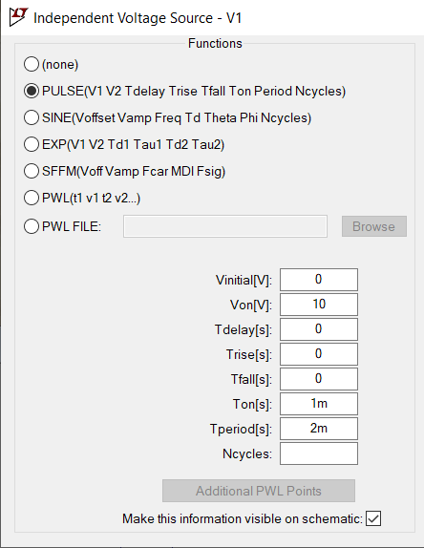

The following are the various circuit cases were considered :

**CASE 1:**

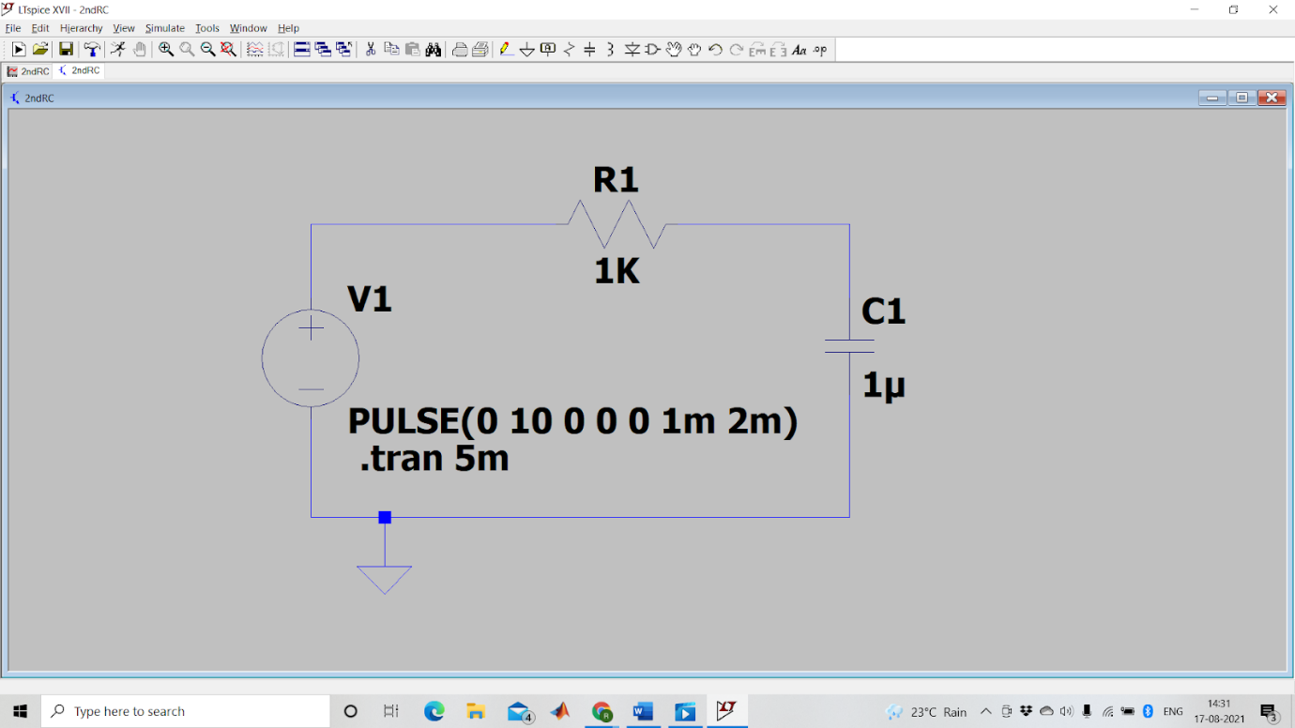

**CASE 2:**

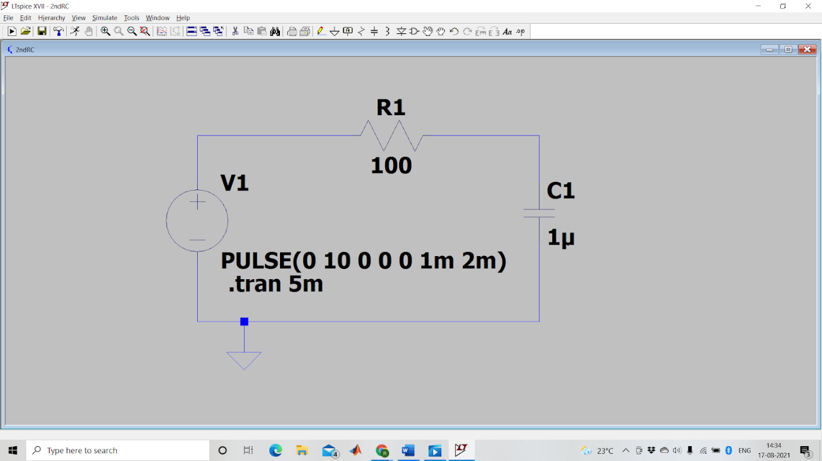

**CASE 3:**

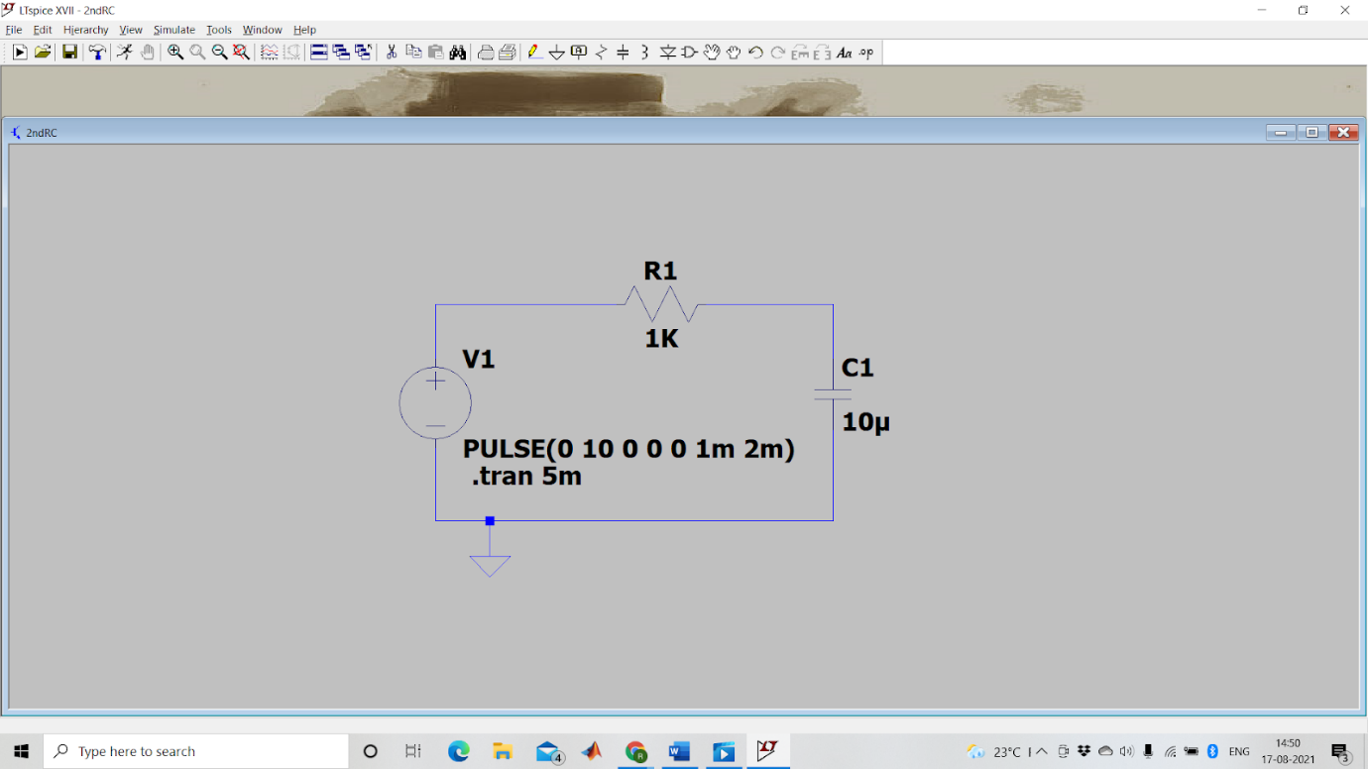

**CASE 4:**

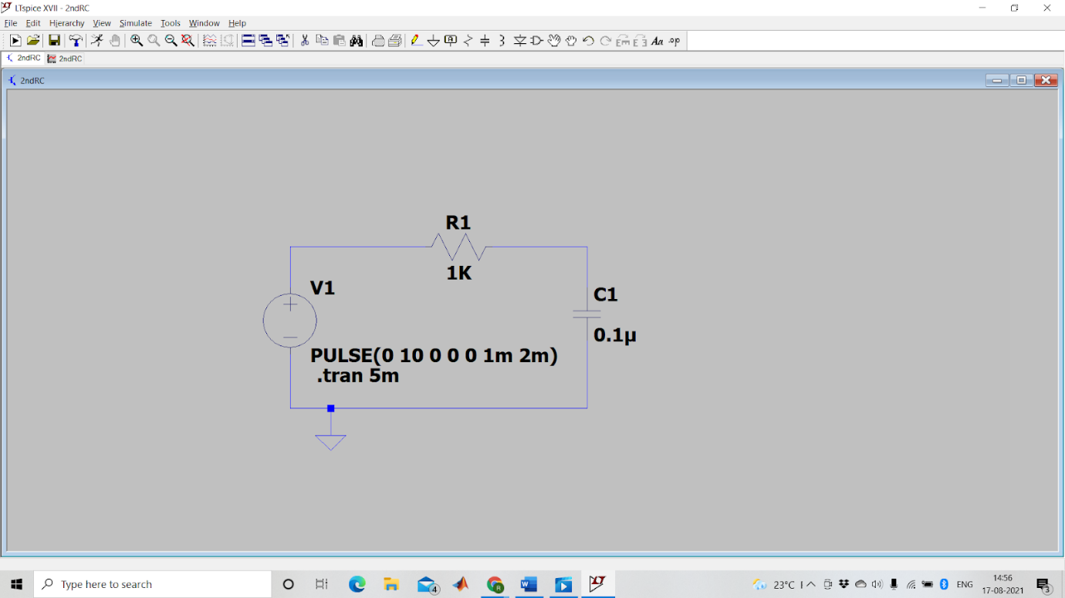

**Results:**

Table for the input parameters

|  |  |  |
| --- | --- | --- |
| Case no. | Resistance (R1 in ohms) | Capacitance (C1 in micro Farad) |
| 1 | 1000 | 1 |
| 2 | 100 | 1 |
| 3 | 1000 | 10 |
| 4 | 1000 | 0.1 |

The following graphs depict the output waveforms of the cases in order

Case 1:

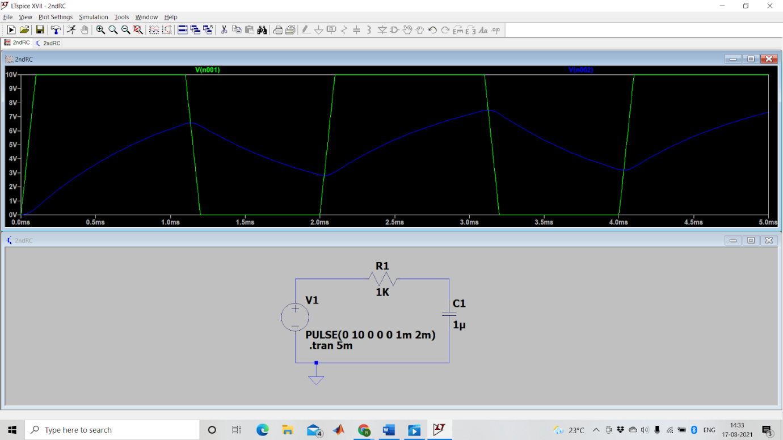

Case 2:

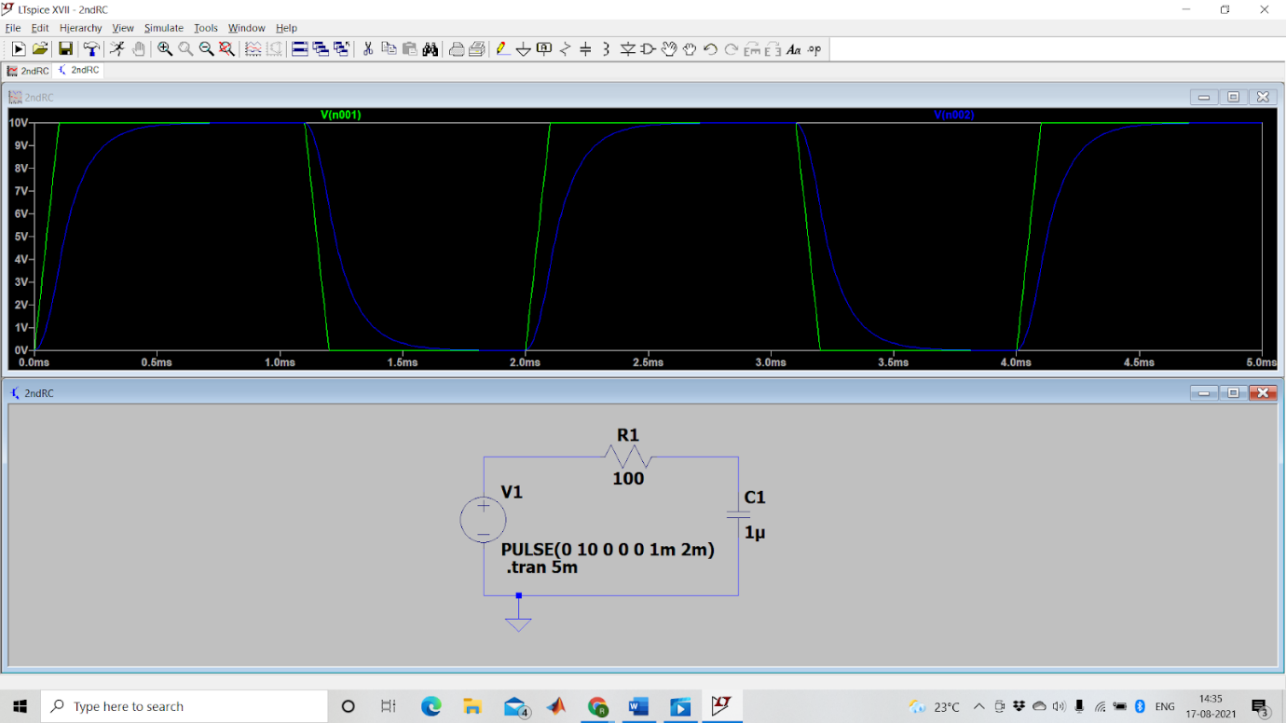

Case 3:

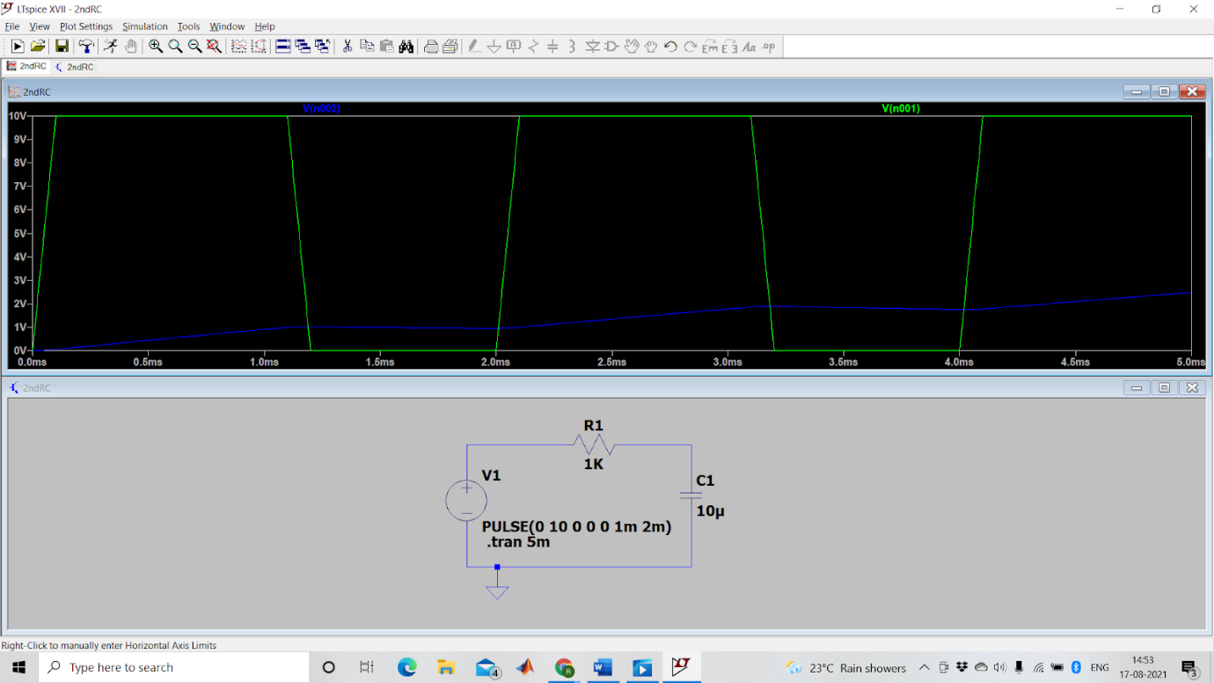

Case 4:

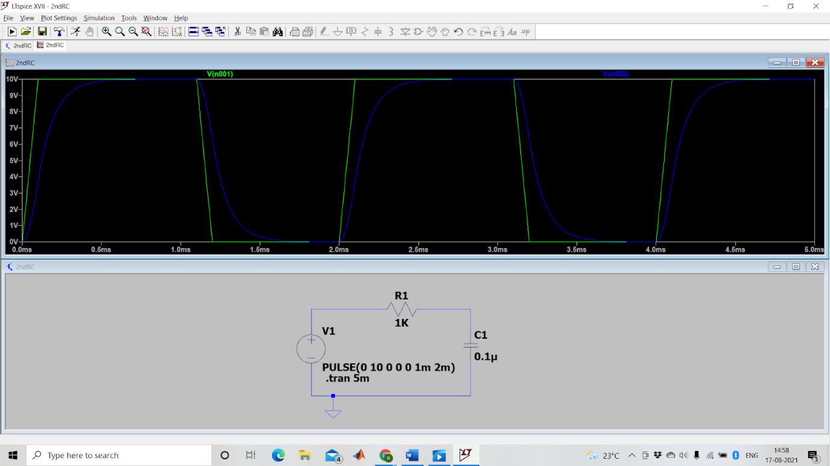

**Discussion:**

In this experiment, we had mainly controlled the inputs by varying the capacitance and the resistance, the product of which is termed as the Time Constant of the circuit. This was done to observe the different outputs and variations on the charging and discharging characteristics of the capacitor using the DC source. The charge stored in a capacitor plate is proportional to the applied voltage and can be defined as,

Q = C × V

where Q is the stored charge, V is the applied voltage, and C is the proportionality constant or known as capacitance. The charging and discharging of capacitor generally take some time and depend on the time constant (τ) of the circuit, i.e R1*C1 in our case.In our circuit, at any point of time (t) the voltage across the capacitor can be given by,

VC =VS(1 – e^(−t⁄τ)).

This equation represented the back end of the simulator. The screenshots of the output waveforms obtained have been pasted in the Result section above.